**Visvesvaraya Technological University**

# Belgaum, Karnataka-590 014



A Mini Project Synopsis on

**“FARM MANAGEMENT SYSTEM”**

**Submitted by**

**KSHAMA BHAKTHA 4CB20CS047**

**NIDHI SHASHI KUMAR 4CB20CS064**



Under the Guidance of

**PROF.VERDINE NORONHA**

**Assistant Professor**

**(Signature)**

**CANARA ENGINEERING COLLEGE**

**Department of Computer Science & Engineering**

**2022-23**

**CANARA ENGINEERING COLLEGE**

**DEPARTMENT OF COMPUTER SCIENCE AND ENGINEERING**

18CSL58-DBMS Laboratory with Mini Project

Mini Project Synopsis

PROJECT TITLE: **FARM MANAGEMENT SYSTEM**

BATCH DETAILS:

| Sl.No | NAME | USN | SIGNATURE |
| --- | --- | --- | --- |
| 1. | Kshama Bhaktha | 4CB20CS047 |  |
| 2. | Nidhi Shashi Kumar | 4CB20CS064 |  |

ABSTRACT

Farm Management System, can lead to error free, secure, reliable and fast management systems. It can be used to store the information about the farm and its supplies. Farm management system is a modern farmer management website application. It helps the farmers to sell their agricultural produce online, providing a wider market and helping them to not restrict themselves to local markets. It can assist the user to concentrate on their other activities rather than concentrating on the record keeping. Thus, it will help organizations in better utilization of resources. The organization can maintain computerized records without redundant entries. That means that one need not be distracted by information that is not relevant, while being able to reach the information. This is a way to store data in an efficient manner.

ENTITY-RELATIONSHIP DIAGRAM

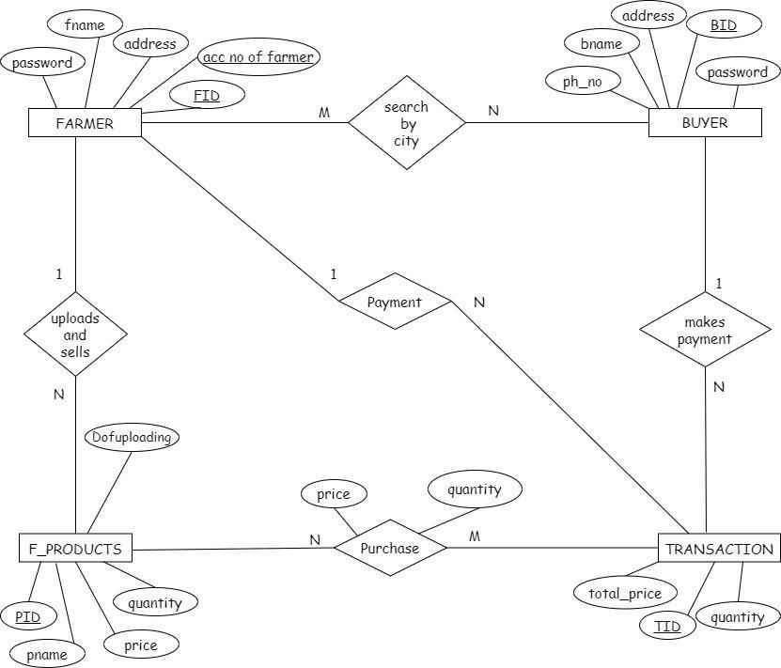

SCHEMA DIAGRAM

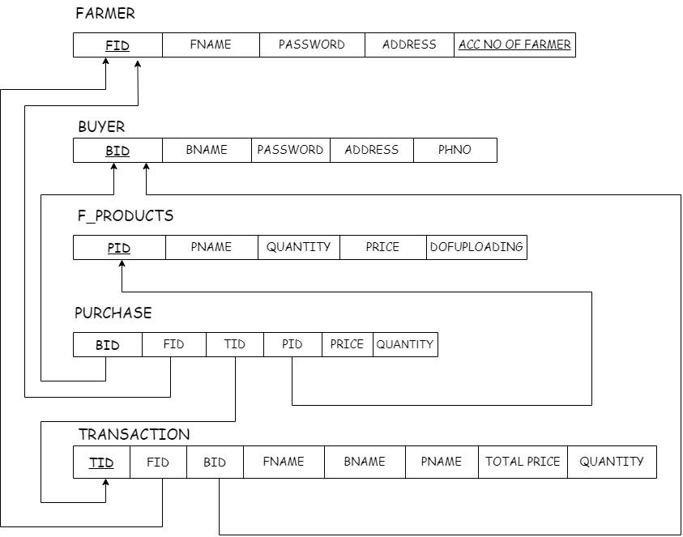

| **SYSTEM REQUIREMENTS** |
| --- |
| **Minimum Hardware Requirements:** |
| A computer with  ● Processor: 1 gigahertz (GHz) or faster processor,  ● RAM: 1 gigabyte (GB) for 32-bit or 2 GB for 64-bit.  ● Hard disk space: 16 GB for 32-bit OS or 20 GB for 64-bit OS |
| **Software Requirements:** |
| Operating system: Windows 98, XP , 7,8 or 10 or Linux  Languages  (Front end): HTML, PHP and Bootstrap  (Back end): SQL  IDE: Notepad++, Xampp and MySQL |

APPLICATION AREA:

1. Marketing of processed Fruits And vegetables.
2. Monitoring of profit and loss.
3. e -Commerce platforms.